Heptagonal Rotunda
# Source: AI Source: Provided by: [Data Path: Persons Table -> ID Column: 1, Name_En Column: Motasem Essam] -> From: [ChatGPT] on [7/25/2026]
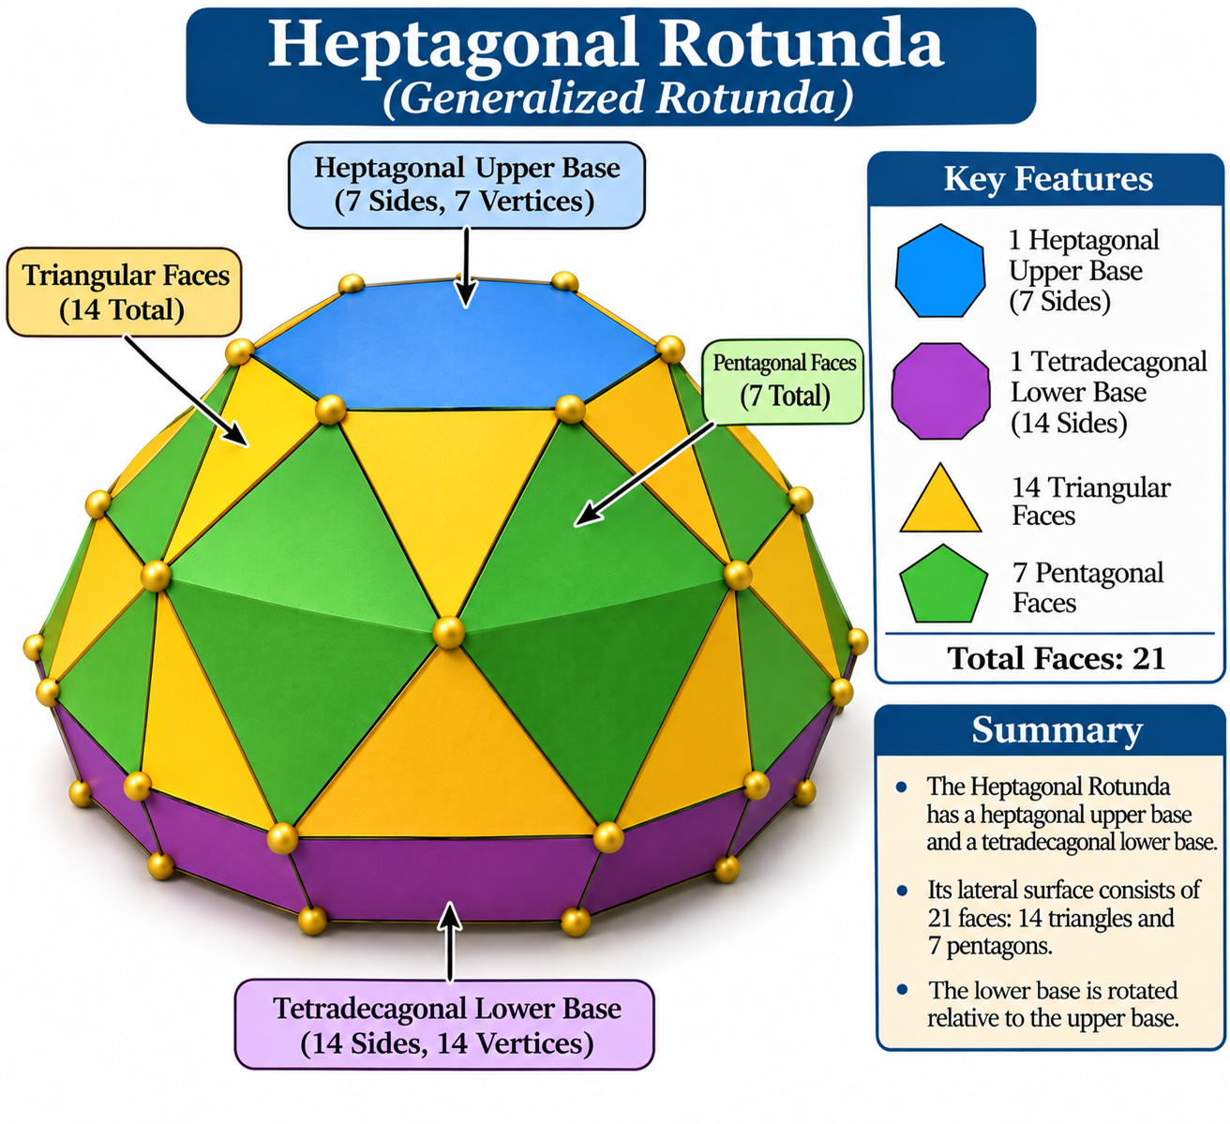

Definition
# Source: AI Source: Provided by: [Data Path: Persons Table -> ID Column: 1, Name_En Column: Motasem Essam] -> From: [ChatGPT] on [7/25/2026]
A Heptagonal Rotunda is a generalized rotunda-type polyhedron constructed with a heptagonal upper base and a parallel tetradecagonal (14-sided) lower base.
Its lateral surface consists of alternating triangular and pentagonal faces arranged around the solid:
- 1 heptagonal upper base.
- 1 tetradecagonal lower base.
- 14 triangular lateral faces.
- 7 pentagonal lateral faces.
The Heptagonal Rotunda follows the generalized rotunda construction. It is not one of the classical Johnson solids; the Pentagonal Rotunda is the classical regular-faced rotunda.

Geometric Structure
# Source: AI Source: Provided by: [Data Path: Persons Table -> ID Column: 1, Name_En Column: Motasem Essam] -> From: [ChatGPT] on [7/25/2026]
The structure is based on two parallel polygonal bases:
- Upper Base: A heptagon with 7 sides.
- Lower Base: A tetradecagon with 14 sides, positioned parallel to the upper base and rotated relative to it.
- Lateral Surface: A band of 21 faces consisting of 14 triangles and 7 pentagons.
The triangular and pentagonal faces alternate around the lateral structure.

Face Composition
# Source: AI Source: Provided by: [Data Path: Persons Table -> ID Column: 1, Name_En Column: Motasem Essam] -> From: [ChatGPT] on [7/25/2026]
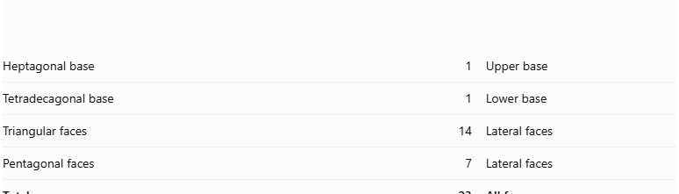
Face Type | Number | Description
Heptagonal base | 1 | Upper base
Tetradecagonal base | 1 | Lower base
Triangular faces | 14 | Lateral faces
Pentagonal faces | 7 | Lateral faces
Total | 23 | All faces

Mathematical Properties
# Source: AI Source: Provided by: [Data Path: Persons Table -> ID Column: 1, Name_En Column: Motasem Essam] -> From: [ChatGPT] on [7/25/2026]
For a generalized rotunda with $n=7$:

Property | Formula | Value
Upper-base sides | $$n$$ | 7
Lower-base sides | $$2n$$ | 14
Triangular faces | $$2n$$ | 14
Pentagonal faces | $$n$$ | 7
Total faces | $$3n+2$$ | 23
Total edges | $$7n$$ | 49
Total vertices | $$4n$$ | 28
Euler's Polyhedron Formula:
$$V-E+F=2$$
$$28-49+23=2$$
The counts satisfy Euler's formula for a topologically spherical polyhedron.

Geometric Characteristics
# Source: AI Source: Provided by: [Data Path: Persons Table -> ID Column: 1, Name_En Column: Motasem Essam] -> From: [ChatGPT] on [7/25/2026]
- Base Shape: Heptagon and tetradecagon.
- Lateral Face Types: Triangles and pentagons.
- Total Faces: 23.
- Total Edges: 49.
- Total Vertices: 28.
- Rotational Symmetry: Sevenfold rotational symmetry in the symmetric arrangement.
- Convexity and Regularity: These depend on the particular geometric realization. The generalized construction does not imply that every face is regular or that all edges have equal length.

Construction of Heptagonal Rotunda

Geometric Instruments Used
# Source: AI Source: Provided by: [Data Path: Persons Table -> ID Column: 1, Name_En Column: Motasem Essam] -> From: [ChatGPT] on [7/25/2026]
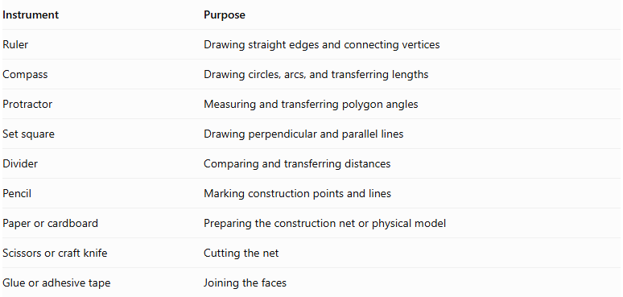
Instrument | Purpose
Ruler | Drawing straight edges and connecting vertices
Compass | Drawing circles, arcs, and transferring lengths
Protractor | Measuring and transferring polygon angles
Set square | Drawing perpendicular and parallel lines
Divider | Comparing and transferring distances
Pencil | Marking construction points and lines
Paper or cardboard | Preparing the construction net or physical model
Scissors or craft knife | Cutting the net
Glue or adhesive tape | Joining the faces

Instrument-Based Construction Procedures
# Source: AI Source: Provided by: [Data Path: Persons Table -> ID Column: 1, Name_En Column: Motasem Essam] -> From: [ChatGPT] on [7/25/2026]
No coordinate-based construction
The construction uses geometric instruments, measured lengths, angles, polygon geometry, and edge matching. It does not use coordinate axes, coordinate points, or coordinate equations.
Important constructibility limitation: A regular heptagon and a regular tetradecagon cannot be constructed exactly using only a compass and straightedge. A protractor-based measured construction or a suitable accurately prepared template is required for these two bases.

Construct the Upper Regular Heptagonal Base
# Source: AI Source: Provided by: [Data Path: Persons Table -> ID Column: 1, Name_En Column: Motasem Essam] -> From: [ChatGPT] on [7/25/2026]
- Draw a circle using a compass.
- Mark its center.
- Use a protractor to divide the full ${360}^{°}$ circumference into seven equal central angles.
- Each central angle measures approximately:
$$\frac{{360}^{°}}{7}≈{51.4286}^{°}$$
- Mark the seven points on the circumference.
- Join consecutive points using a ruler.
- Verify that the seven sides are approximately equal.
- Label the vertices $A,B,C,D,E,F,G$.

Construct the Lower Regular Tetradecagonal Base
# Source: AI Source: Provided by: [Data Path: Persons Table -> ID Column: 1, Name_En Column: Motasem Essam] -> From: [ChatGPT] on [7/25/2026]
- Draw a second circle using a compass.
- Mark its center.
- Divide the circumference into fourteen equal central angles using a protractor.
- Each central angle measures approximately:
$$\frac{{360}^{°}}{14}≈{25.7143}^{°}$$
- Mark the fourteen points on the circumference.
- Join consecutive points using a ruler.
- Verify that the fourteen sides are approximately equal.
- Label the vertices $P_{1},P_{2},…,P_{14}$.

Construct the Fourteen Triangular Lateral Faces
# Source: AI Source: Provided by: [Data Path: Persons Table -> ID Column: 1, Name_En Column: Motasem Essam] -> From: [ChatGPT] on [7/25/2026]
- Prepare fourteen triangular faces using a ruler, compass, and protractor.
- Determine their side lengths and angles from the selected Heptagonal Rotunda model.
- Arrange the triangles according to the intended lateral face pattern.
- Match their edges to the appropriate edges of the pentagonal faces and bases.
- Verify that each triangle fits its neighboring faces without gaps or unintended overlaps.

Construct the Seven Pentagonal Lateral Faces
# Source: AI Source: Provided by: [Data Path: Persons Table -> ID Column: 1, Name_En Column: Motasem Essam] -> From: [ChatGPT] on [7/25/2026]
- Prepare seven pentagonal faces.
- Determine their side lengths and interior angles from the selected model.
- Arrange the pentagons alternately within the lateral face arrangement.
- Match their edges with the appropriate neighboring triangular faces.
- Verify that the seven pentagons complete the lateral structure correctly.

Arrange the Faces
# Source: AI Source: Provided by: [Data Path: Persons Table -> ID Column: 1, Name_En Column: Motasem Essam] -> From: [ChatGPT] on [7/25/2026]
- Position the regular heptagonal upper base and regular tetradecagonal lower base parallel to each other.
- Arrange the fourteen triangles and seven pentagons between the two bases.
- Check the lengths of all shared edges.
- Verify the intended sevenfold rotational arrangement.
- Confirm that every edge belongs to exactly two faces and that the surface closes without gaps or overlaps.

Assemble the Solid
# Source: AI Source: Provided by: [Data Path: Persons Table -> ID Column: 1, Name_En Column: Motasem Essam] -> From: [ChatGPT] on [7/25/2026]
- Prepare a verified construction net or separate face pieces with the correct adjacency arrangement.
- Add joining tabs if using paper or cardboard.
- Cut out the faces.
- Fold the required edges if using a net.
- Join the matching lateral faces.
- Attach the upper heptagonal base and lower tetradecagonal base.
- Inspect the completed model from several directions.
Construction accuracy: The seven pentagons and fourteen triangles must have dimensions and angles compatible with the selected generalized model. Simply using regular pentagons, equilateral triangles, a regular heptagon, and a regular tetradecagon does not guarantee a valid closed Heptagonal Rotunda. The face geometry and adjacency must be verified before assembly.

Key Points
# Source: AI Source: Provided by: [Data Path: Persons Table -> ID Column: 1, Name_En Column: Motasem Essam] -> From: [ChatGPT] on [7/25/2026]
- The Heptagonal Rotunda has a 7-sided upper base and a 14-sided lower base.
- Its lateral surface contains 14 triangles and 7 pentagons.
- It has 23 faces, 49 edges, and 28 vertices.
- It is a generalized rotunda, not a classical Johnson solid.
- The Pentagonal Rotunda is the classical rotunda with all faces regular.

Main Classification
# Source: AI Source: Provided by: [Data Path: Persons Table -> ID Column: 1, Name_En Column: Motasem Essam] -> From: [ChatGPT] on [7/25/2026]
Solid Geometry
└── Types of Solids
└── Rotunda
└── Types of Rotundas
└── Heptagonal Rotunda
├── Heptagonal Upper Base
├── Tetradecagonal Lower Base
├── Triangular Lateral Faces
└── Pentagonal Lateral Faces

Conclusion
# Source: AI Source: Provided by: [Data Path: Persons Table -> ID Column: 1, Name_En Column: Motasem Essam] -> From: [ChatGPT] on [7/25/2026]
The Heptagonal Rotunda is a generalized rotunda-type polyhedron with a heptagonal upper base, a tetradecagonal lower base, and an alternating arrangement of triangular and pentagonal lateral faces. Its topology gives it 23 faces, 49 edges, and 28 vertices.

